=>LLM Hallucination:  
->whenever an llm doesn’t know the information then it takes help of tools and external databases and RAG  
->Human verification is a simple method to evaluate answers  
**->LLM hallucination** is when a large language model **generates information that sounds confident and fluent but is incorrect  
=>RAG :  
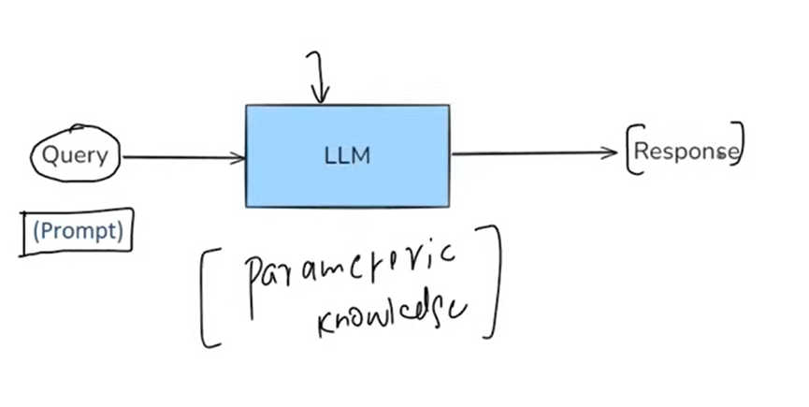  
->LLM’s are probabilistic models , thus we see that the outputs are also sometimes incorrect  
Disadv of fine-tuning:  
->it is computationally expensive task  
->if db is updated then pre-training has to be performed once again  
=>In-Context Learning:  
->llm’s learn to solve a task purely by seeing examples in the prompt without updating its weights  
=>Emergent Property:  
->It is ability that suddenly appears in a system when it reaches a certain scale or complexity – even though it was not explicitly programmed  
->There is a research paper called “llm’s are few short learners” which states that GPT-3 has the ability to learn from examples provided from prompts  
->RAG means it is a way to make a LLM like GPT to smarter by giving it extra information at the time you ask your question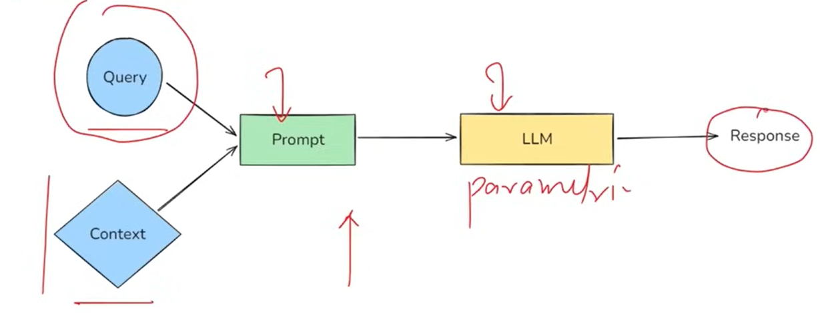 ->RAG = information retrieval + text generation  
->It consists of 4 components:**

**1.Indexing  
2.Retrieval  
3.Augmentation  
4.Generation  
  
1. Indexing:   
->It is the process of preparing your knowledge base so that it can be efficiently searched at query time  
a)Document Ingestion: Load your source knowledge into memory  
There are LangChain Loaders to perform this  
b)Text Chunking : It means breaking the large documents into small, semantically meaningful chunks  
That is coz llm’s have token limits  
c)Embedding Generation:   
d)Storage in Vector Storage: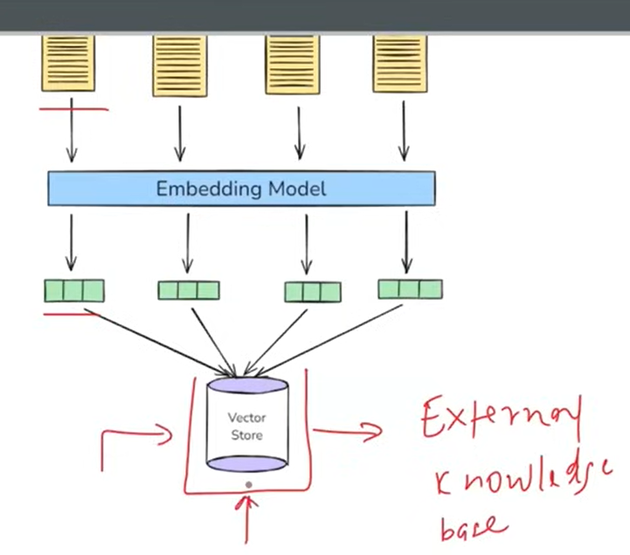 2. Retrieval:**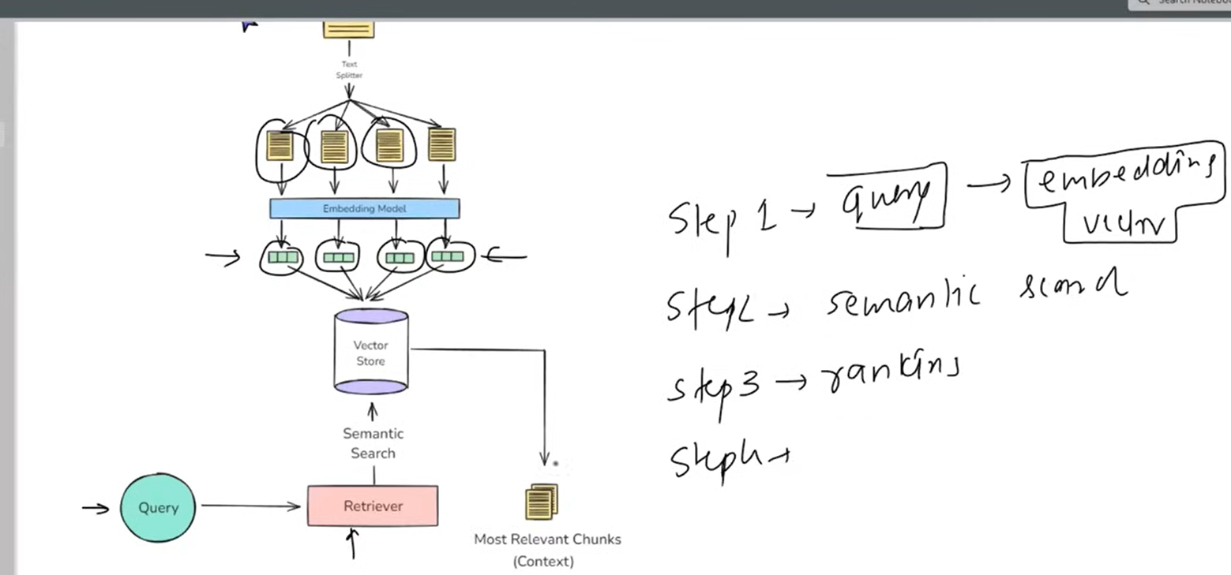

**3. Augmentation:**

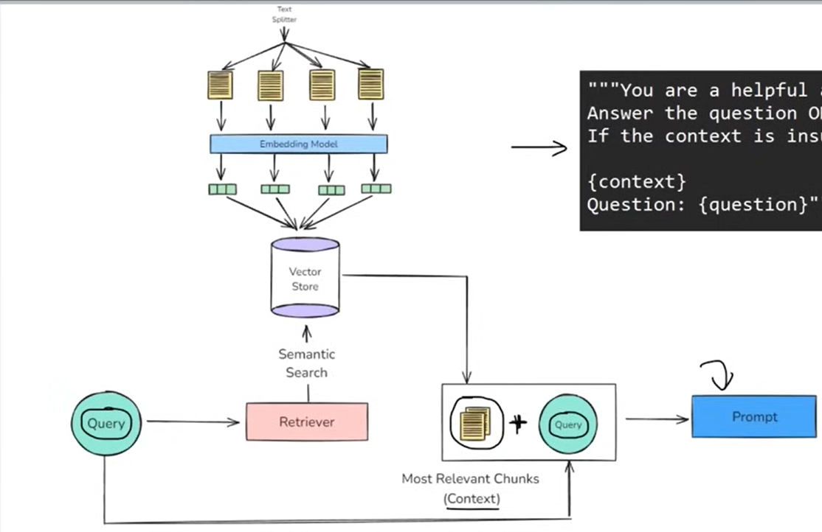

4. Generation:  
 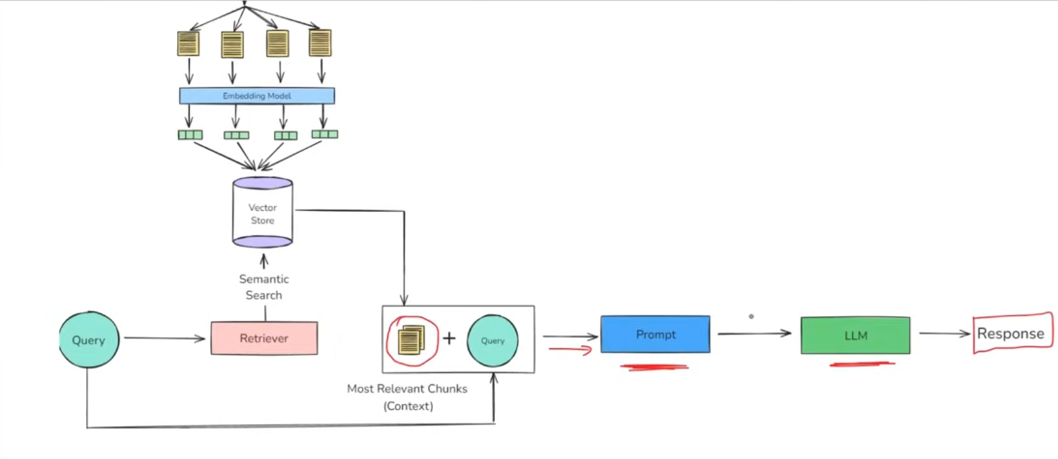

=>Generative AI :  
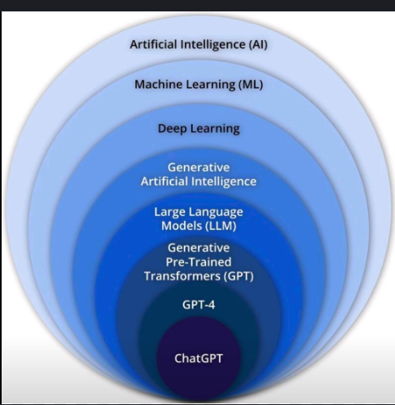  
->LLm’s focus only on text processing and text generation  
-> Generative AI is a subset of AI that focuses on generating new and realistic content such as text, images, audio, and code using learned data patterns   
->Foundational models is the core concept in Gen ai  
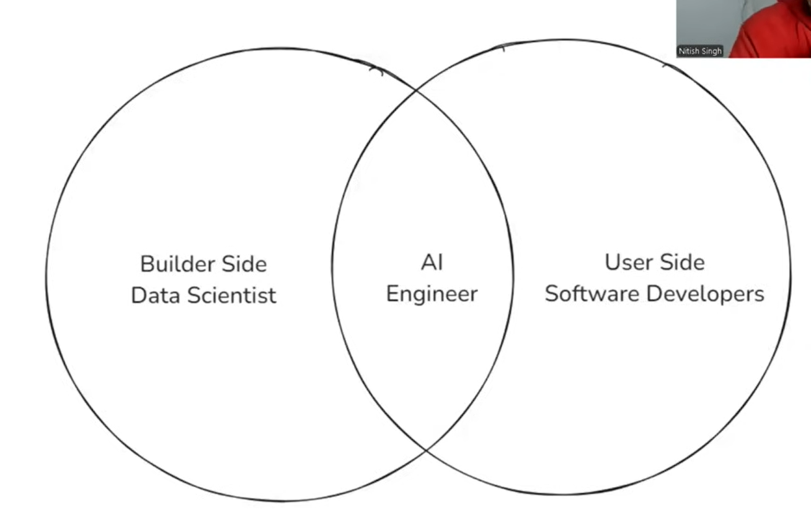  
->Langchain is an open source framework that helps in building llm based applications  
Benefits of LangChain:  
1. Concept of Chains  
2. Model Agnostic Dev  
3. Complete Ecosystem  
4. Memory and state handling  
=>LangChain components:  
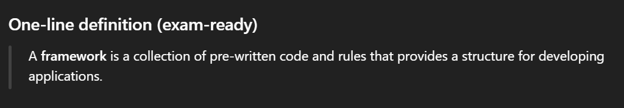  
  
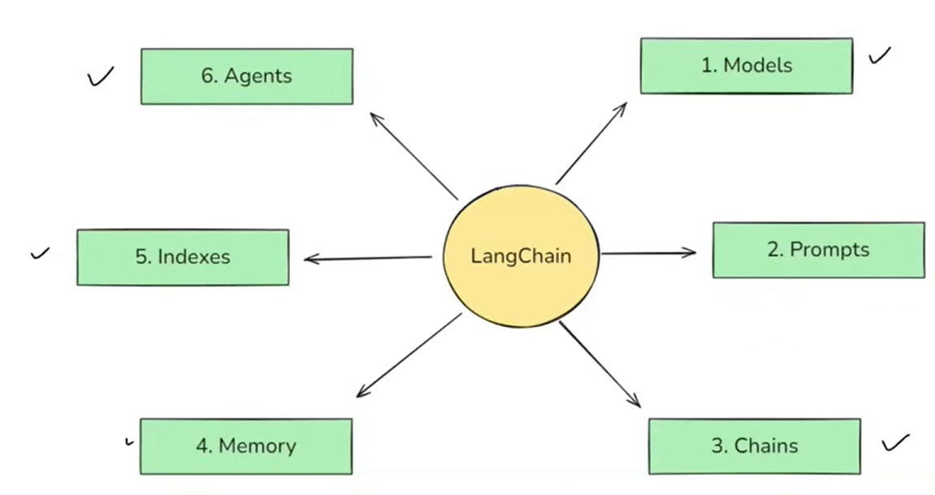  
1. Models:  
-> In LangChain ‘models’ are the core interfaces through which you interact with AI models  
->LangChain models can communicate with 2 types of models:

a) LLM

b) Embedding models (they give vector as an model)

2.Prompts   
3.Chains :  
->It is used to build pipelines  
->Chains used to convert output of one stage into input for another stage  
->We can make complex pipelines: Parallel Chain and Conditional Chain

4. Indexes:  
->It connects your application to external knowledge – such as PDF’s, websites or databases  
->It consists of :  
>>doc loader  
>>text splitter  
>>vector store  
>>retrievers  
  
5. Memory:  
->LLM API calls are stateless  
->Stateless means it keeps forgetting the context every now and then  
->let us explore few solutions :-  
a)Conversation Buffer Memory : storing the transcript of recent messages  
b)Conversation Buffer Window Memory :- Only keeps the last N interactions   
c)Summarizer Based Memory   
d)Custom Memory :- ex:- key facts or user preferences  
  
6. Agents:  
->It is a chatbot with reasoning capability and tools  
  
=>MODELS:  
->It is a crucial part of the framework, designed to facilitate interactions with various language models and embedding models  
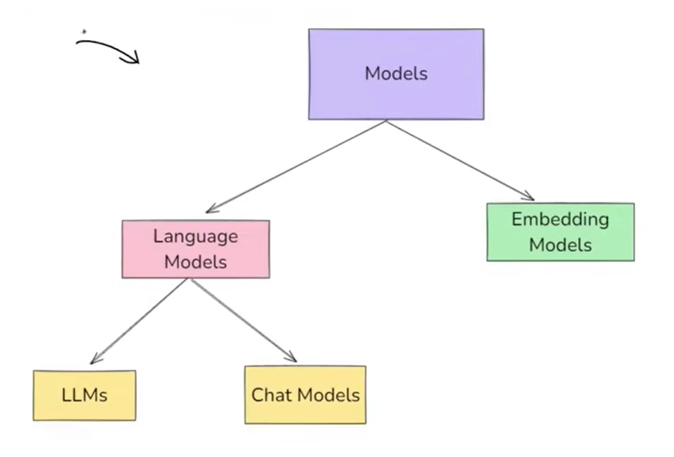

->Language models :- It refers to AI system that take text as input and also output   
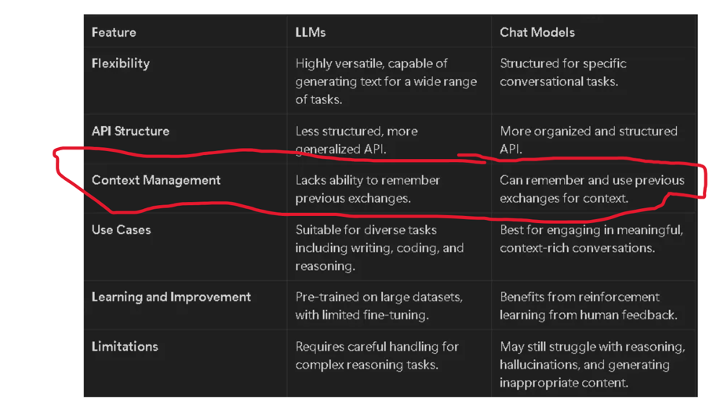  
=>Open Source Models:  
->These are freely available AI models that can be downloaded , modified , fine-tuned , and deployed without restrictions from a central provider  
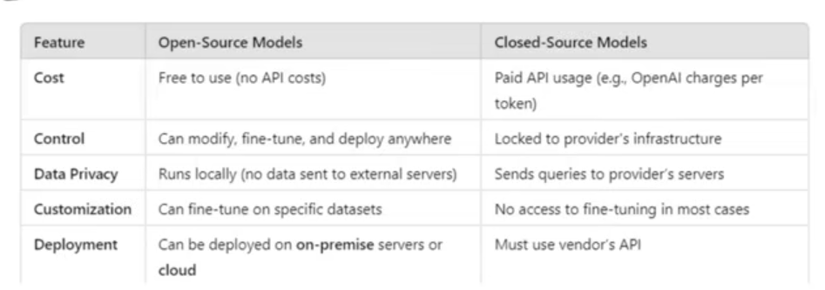

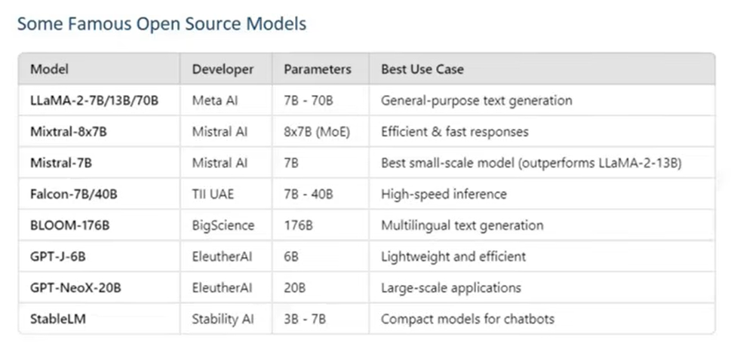

=>Hugging Face:-   
->It is the largest repository of open source LLMs  
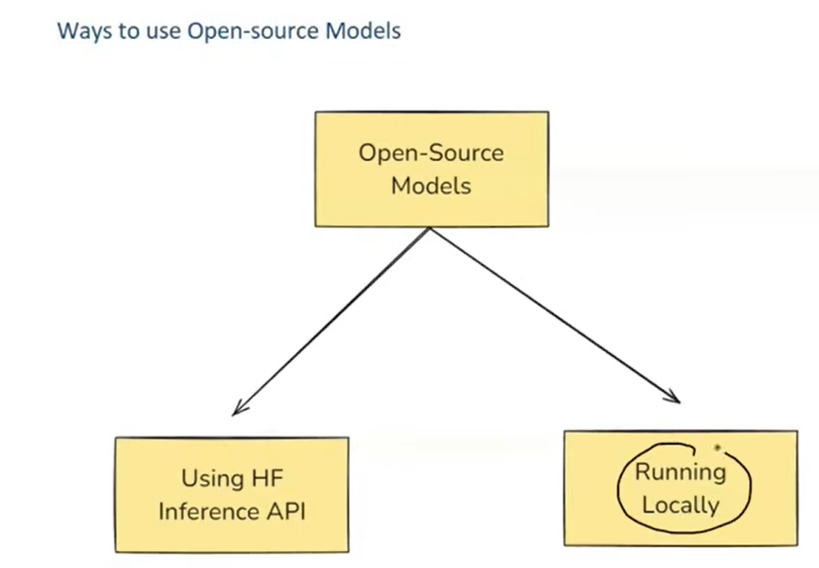  
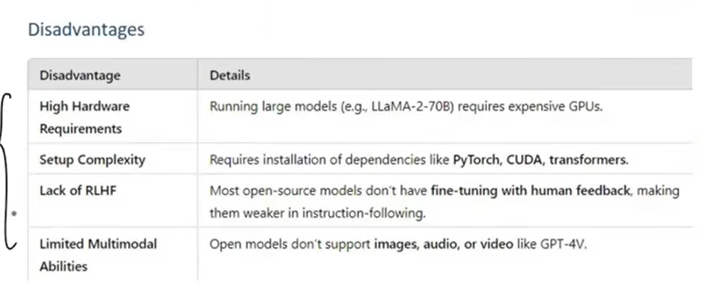  
  
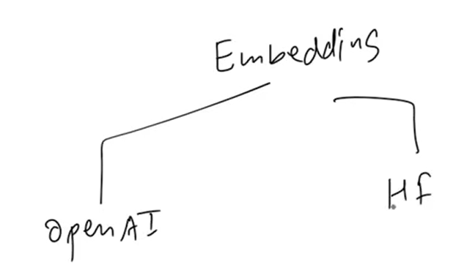  
->Embedding models are very useful to perform semantic search

=>Prompts:  
->These are input instructions given to a model to guide its output  
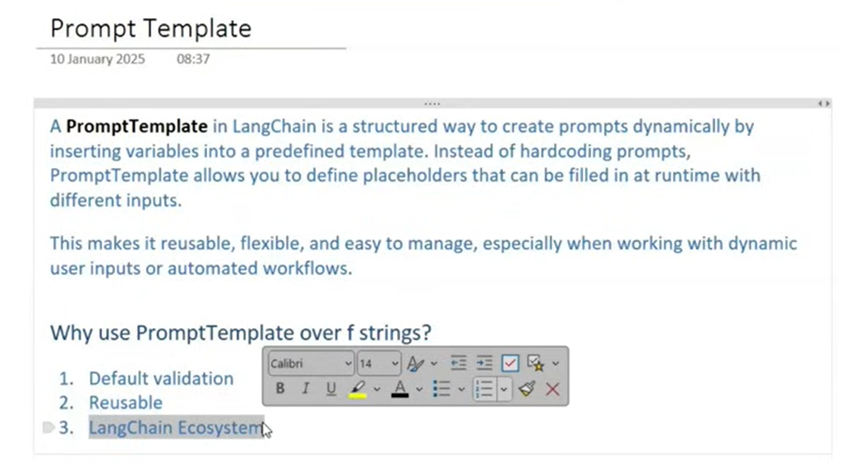

=>Generative AI :  
-> Generative AI is a subset of AI that focuses on generating new and realistic content such as text, images, audio, and code using learned data patterns  
->Traditional AI is about finding patterns in data and giving predictions  
=>Problems of Gen AI:  
->Reactive but not proactive  
->No memory  
->Generic Advice  
->can’t take actions  
=>Agentic AI :  
-> **Agentic AI** is type of proactive **AI** that can **act** make decisions, planning actions, and executing tasks to achieve a specific goal with minimal human intervention  
=>Characteristics:  
->Autonomous  
->Goal Oriented  
->Planning  
->Reasoning  
->Adaptability  
->Context Awareness  
  
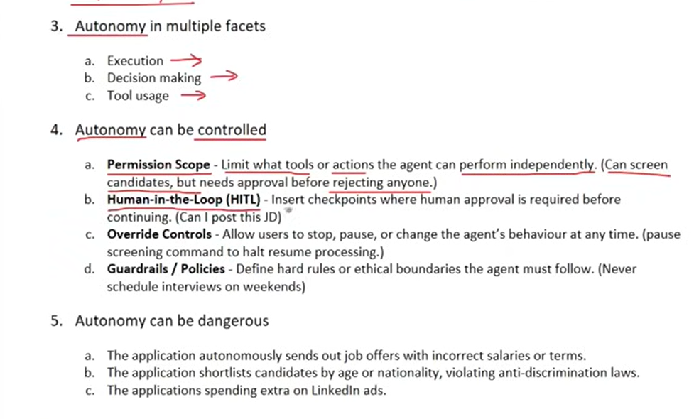

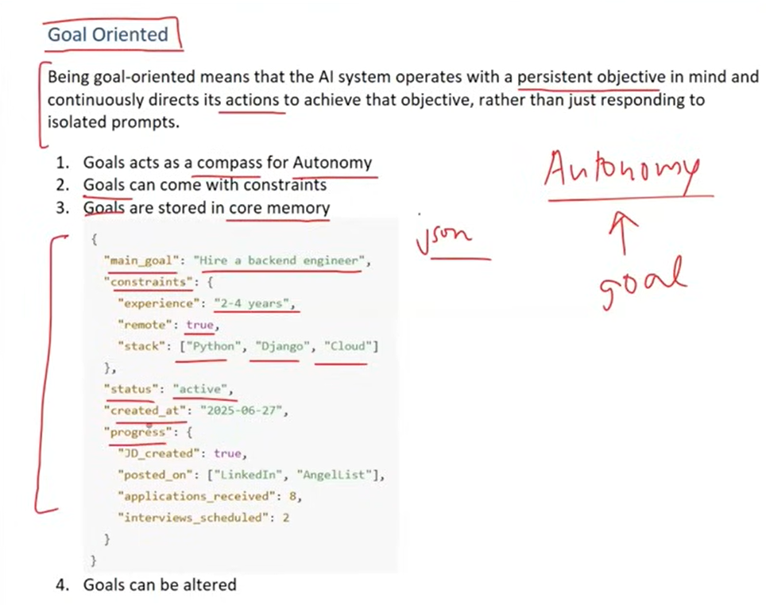  
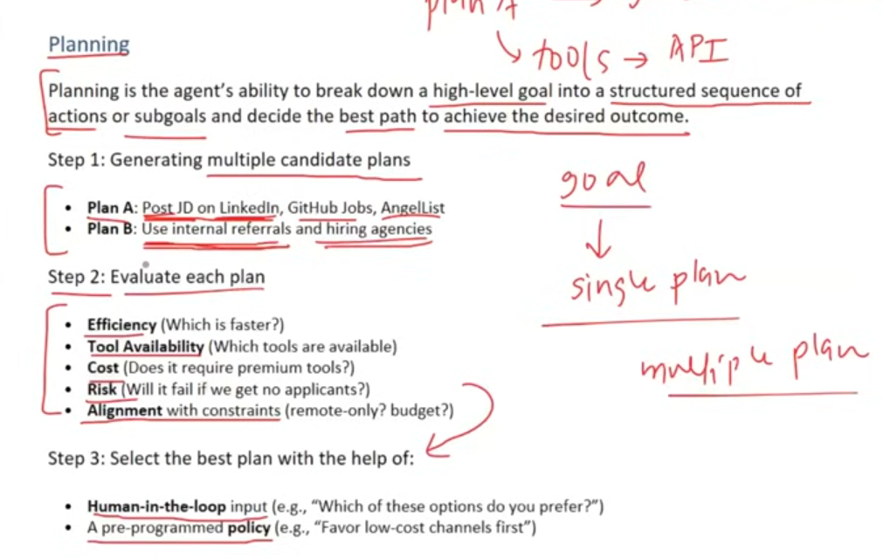

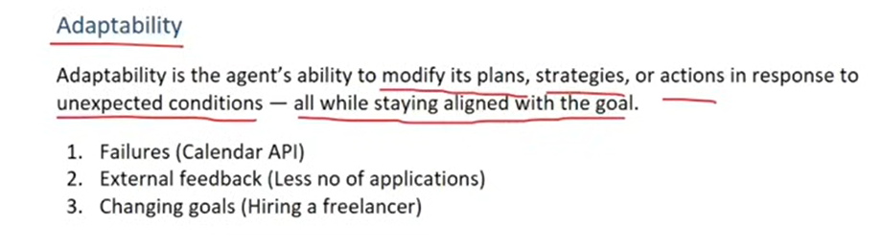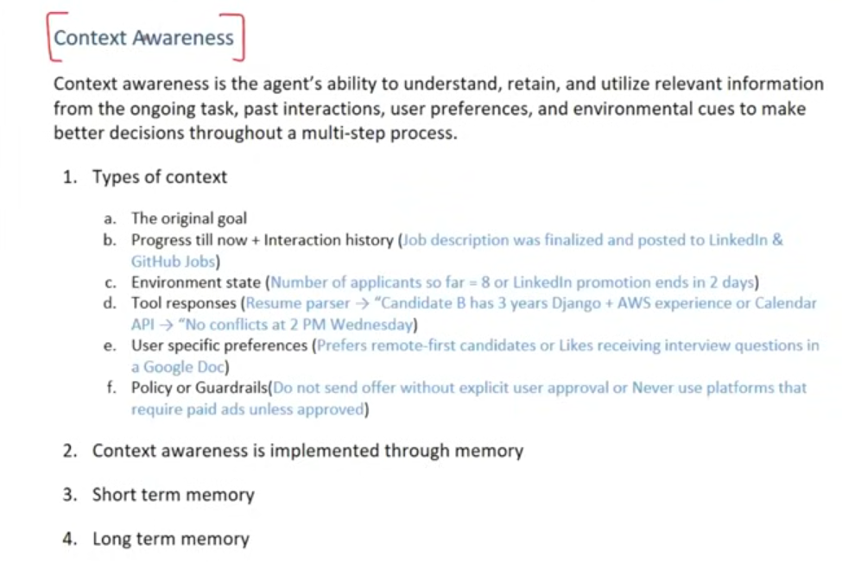=>Components of Agentic AI:  
->Brain (generally it is an LLM)  
->Orchestrator (Executing the tasks)  
->Tools (API calls or to perform RAG)  
->Memory (short term , long term , state tracking )  
->Supervisor (Human In The Loop)  
  
=>Challenges of Langchain:  
1. Control Flow Complexity:  
->conditional branch  
->loops  
->jump  
2. Handling State:  
->tracking the progress so far by maintaining dictionary (k-v pairs) in manual way  
->LangChain is stateless  
3. Event Driven Execution :  
->Langchain is built for sequential workflow , which means it completes the execution without any waiting

->LangChain cannot help us with event driven workflow which means we cannot wait until a particular event occurs  
4. Fault Tolerance:  
->LangGraph helps Maintaining states that helps to recover and retry from the old node  
5.Human In The Loop:  
-> LangGraph helps to pause for lot of time until we get human approval  
6. Nested Workflows :   
->Sometimes each node may again consists of separate workflow  
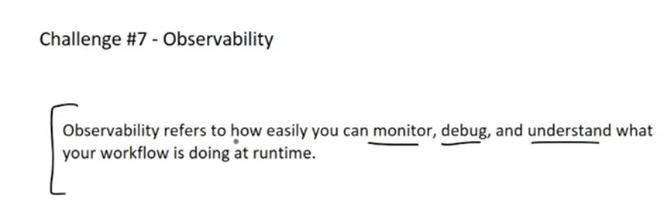  
=>Core Concepts:  
-> LangGraph is an Orchestration framework for building intelligent, stateful , and multi-step LLM workflow  
-> It enables advanced features like parallelism, loops , branching , memory and resumability  
->It models your logic as a graph of nodes and edges instead of linear chain  
=>LLM workflow:  
->Workflow is defined as a series of tasks to achieve a goal  
->A workflow which uses LLM for its execution will become LLM workflow  
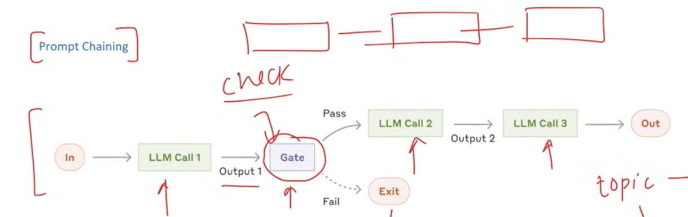  
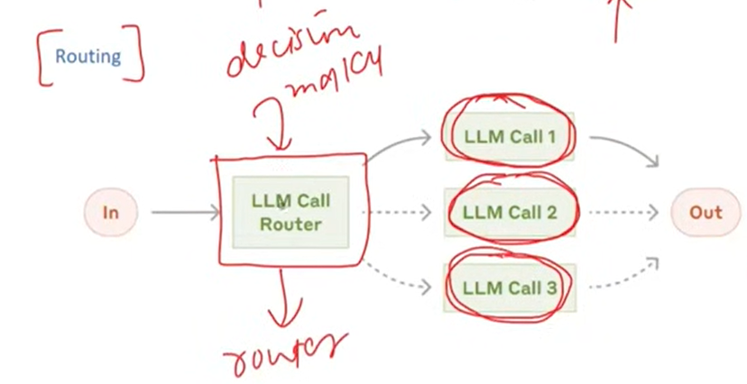

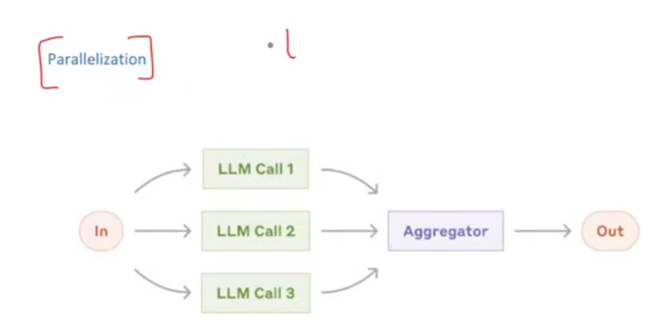  
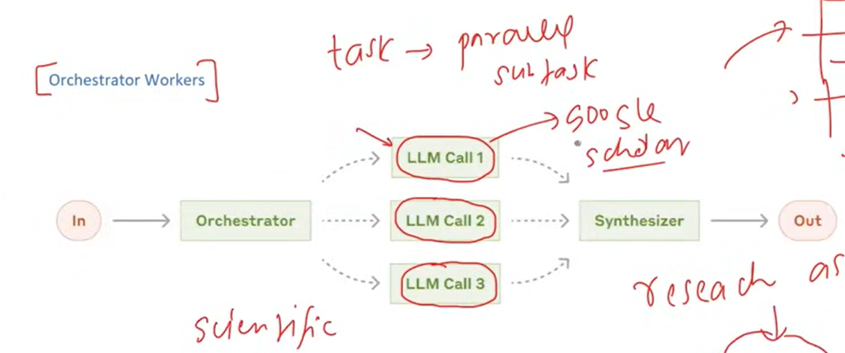  
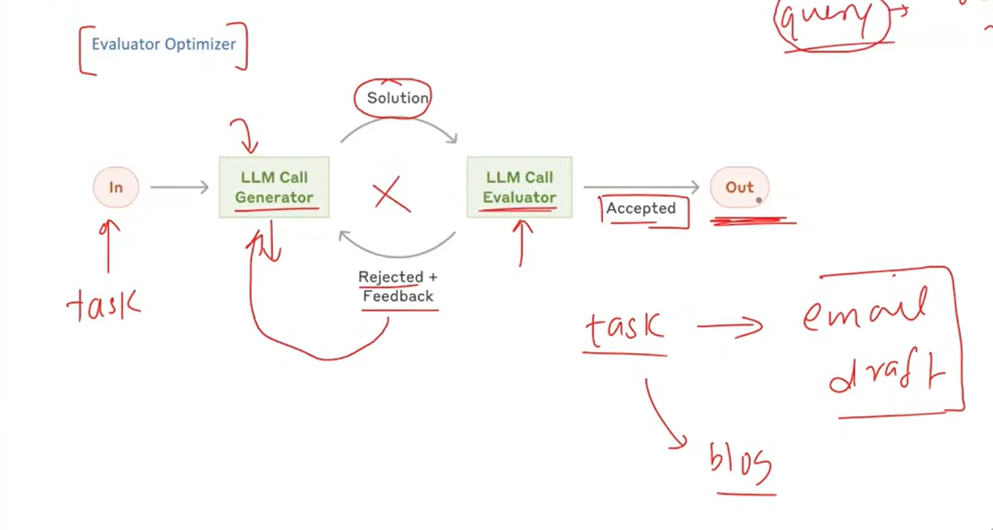

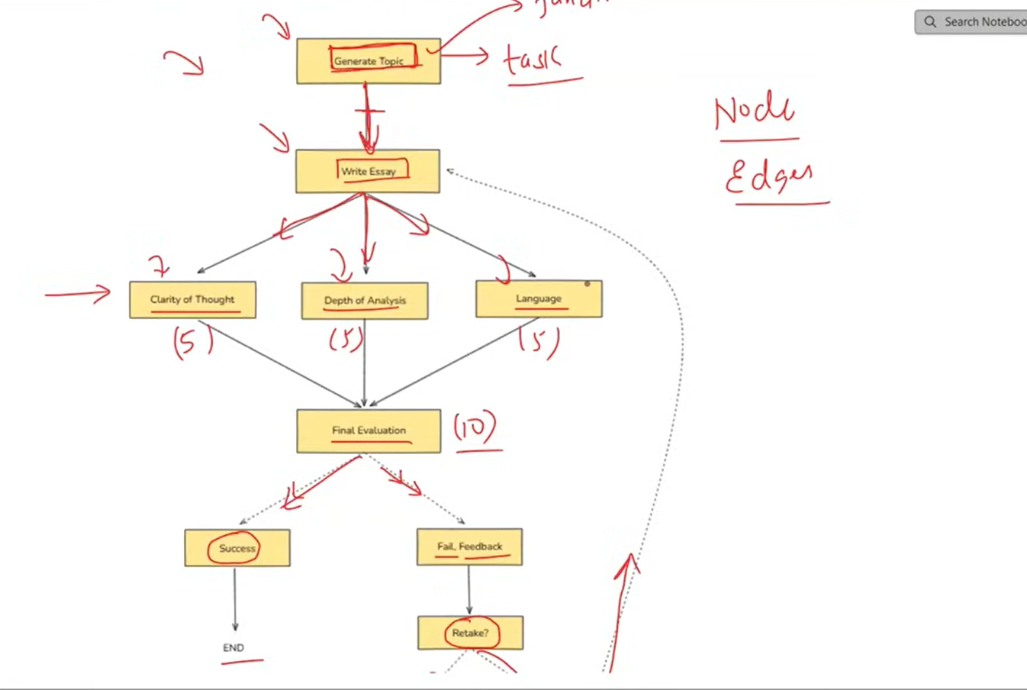

->Node :- It represents the task to be performed  
->Edge :- It represents when a task will be performed  
->State :- It is the memory that flows through your workflow and it holds all the data being passed between nodes as your graph runs  
->Every node performs takes state as an input and performs updations to the state  
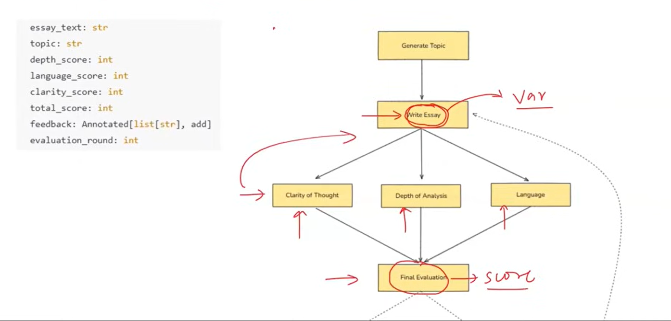

=>Reducers:  
->It defines what type of updation will be performed :  
Update , Replace or Merge   
->Example in case of chatbot better to add rather than update  
  
=> LangGraph Execution Model:  
1. Graph Definition  
2. Compilation  
3. Invocation   
4. Super – Steps begin  
5. Message passing and node activation  
6. Halting condition  
  
->In sequential workflow we return the state but in parallel workflow we return the k,v pair of the updation corresponding to the state  
  
=>Persistence :  
->It refers to the ability to save and restore the state of a workflow overtime  
->As soon as we reach the final state all the values in the state dictionary will get erased  
->we need to store every intermediate node’s state values   
=>Checkpointers in persistence :  
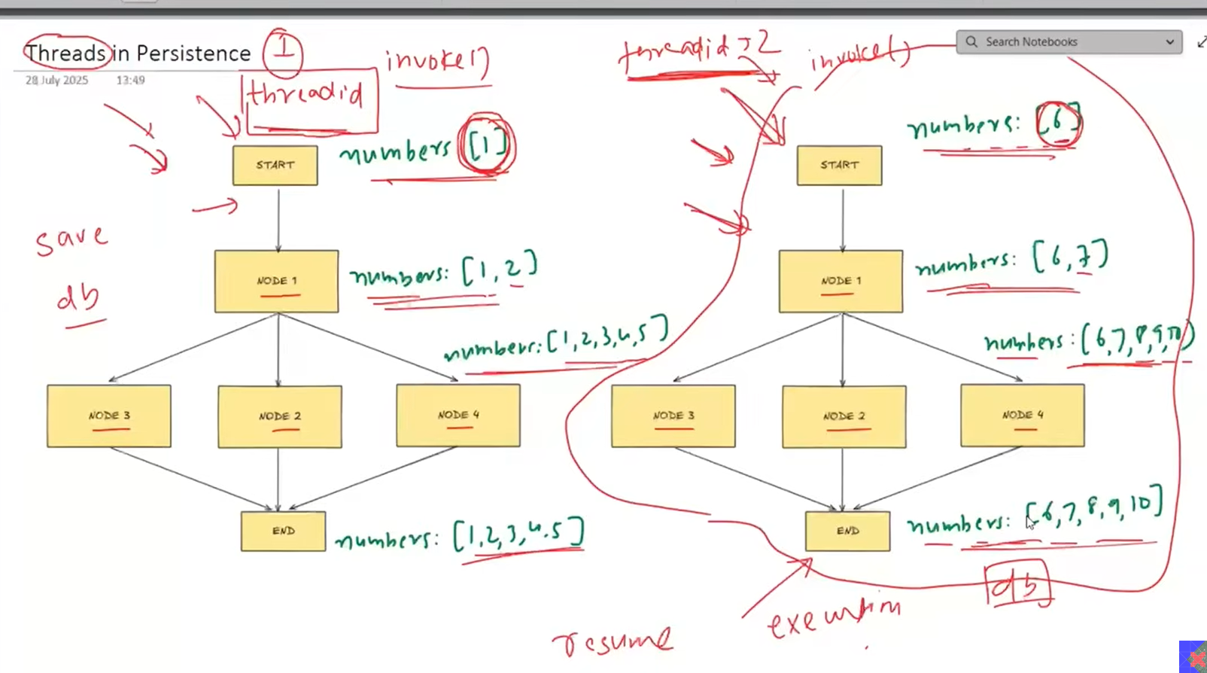  
->If we keep adding things to a database then that would lead to mess  
->we may not be able to differentiate between 1st workflow and 2nd workflow  
->To clearly distinguish bw them we use concept of threads   
->We assign thread-ids  
  
  
  
=>Adv Of Persistance :-  
->Short term memory  
->Fault Tolerance  
->HITL  
->Time Travel